Table of Contents
Project overview 2
Introduction 3
Laravel: 3
PHP 3
Vscode: 3
Xampp: 3
Composer 3
Laravel view 3
Evidence and development of component-1 4
Evidence for php installation 4
Evidence for xampp installation 5
Evidence of vs code installation 5
Evidence for outcome of component-1 6
Evidence and development of component -2 7
Evidence of view 7
Evidence of route 9
Evidence of controller 9
Evidence of version control 9
Component-3 11
evidence of ui/ux 11
evidence of model and migration 12
evidence of factories/seeders 13
evidence of routing 13
evidence of view 14
evidence of controller 14
evidence of authentication 15
evidence of password reset 15

Project overview
The aim of this project is to build simple web application using Laravel framework. The entire project is divided into 3 major components i.e., component-1, component-2, and component-3.
Component-1 is about setting up development environment, linking code to GIT, demonstrated through a short PHP task.
Component-2 is an extension of Component 1 and using Laravel as a Framework for working with views and data.
That required to:
- embed component-1 files into a Laravel Project - the structure already used will map into Laravel.
- create a front end (views) that will allow a user to perform CRUD operations
- products should be displayed with a reusable template (i.e. card)
- follow good practice and naming conventions for defining your routes, and methods in the controller
Component-3 extends on the component-2 exercises and required to now remove the json file and replace with models and a database. New functionality has to be added authentication and allow for a differentiation in customer and admin type roles. It is optional whether to keep Blade based templates as used in Component 2 or move to an API type scenario and respond directly with json formatted data to Vue driven clients.

Introduction

Laravel:
Laravel is a PHP based web framework for building high-end web applications using its significant and graceful syntaxes. It comes with a robust collection of tools and provides application architecture. Moreover, it includes various characteristics of technologies like ASP.NET MVC, CodeIgniter, Ruby on Rails, and many more. This framework is an open-source framework. It facilitates developers by saving huge time and helps reduce thinking and planning to develop the entire website from scratch.

PHP
Php stand for Hypertext Preprocessor" widely-used as an open-source scripting language which are executable on the server. Php file contain text, HTML, CSS, JavaScript. PHP code executed on the server, and the result is returned to the browser as plain HTML and has .php extension. php can generate dynamic page content, encrypt data, send and receive cookies, used to control user-access and runs on various platforms like (Windows, Linux, Unix, Mac OS X, etc.)

Vscode:
Visual Studio Code is a lightweight but powerful source code editor which is available for Windows, macOS and Linux. It comes with built-in support for JavaScript, TypeScript and Node.js and has a rich ecosystem of extensions for other languages (such as C++, C#, Java, Python, PHP, Go) and runtimes (such as .NET and Unity).

Xampp:
Xampp is an open-source web server solution software developed by Apache, it mainly consists of Apache HTTP server, MariaDB database, and scripts interpreters written in the PHP and Perl programming language

Composer
The Composer is a dependency manager or dependency management tool specifically built for PHP. Using Composer, makes us easy to download and incorporate useful and essential packages (stable libraries created by other developers) into your project via the terminal.

Laravel view
Views contain the HTML part served by Laravel application, and serve as a convenient method of separating your controller and domain logic from your presentation logic. Views are stored in the resources/views directory.

Evidence and development of component-1
In component-1 I’ve been provided with dummy code written in php which consist CDs and book product which is extended from shop product now I’ve been asked to add new game product file.
I’ve setup an environment for the development of php project for that I’ve install following set of software
- php.
- xampp.
- Vs code.
- X-debugg

Evidence for php installation
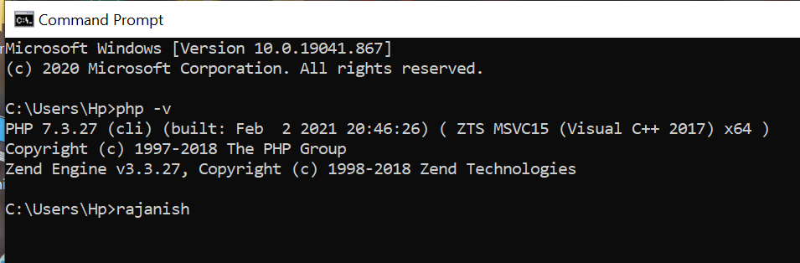

Evidence for xampp installation

Evidence of vs code installation

Evidence for outcome of component-1
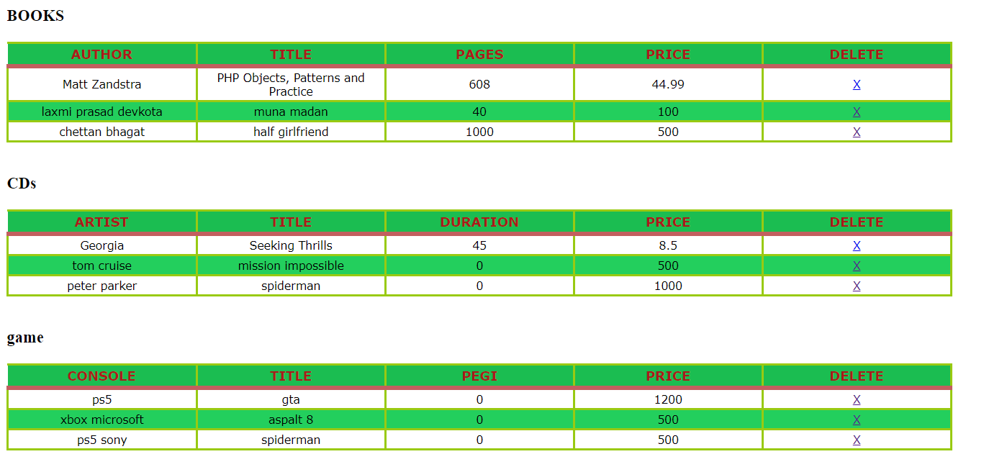
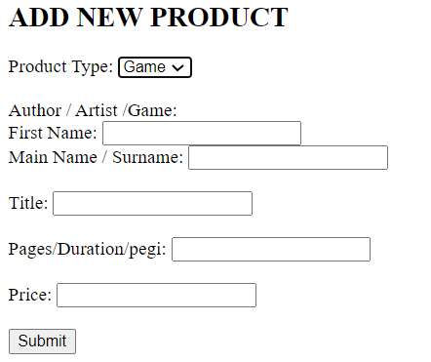

Evidence and development of component -2
In this component I need to implement Laravel framework (view, controller and route).
With proper naming conventions to develop web application that perform CRUD operation. First of all i need to set development environment for Laravel project for that we need
- Php.
- Composer.
- Vs-code.
- Laravel installer.
After environment setup I created project folder, Open the folder in vs-code to create view, controllers, route required for the application development.

Evidence of view
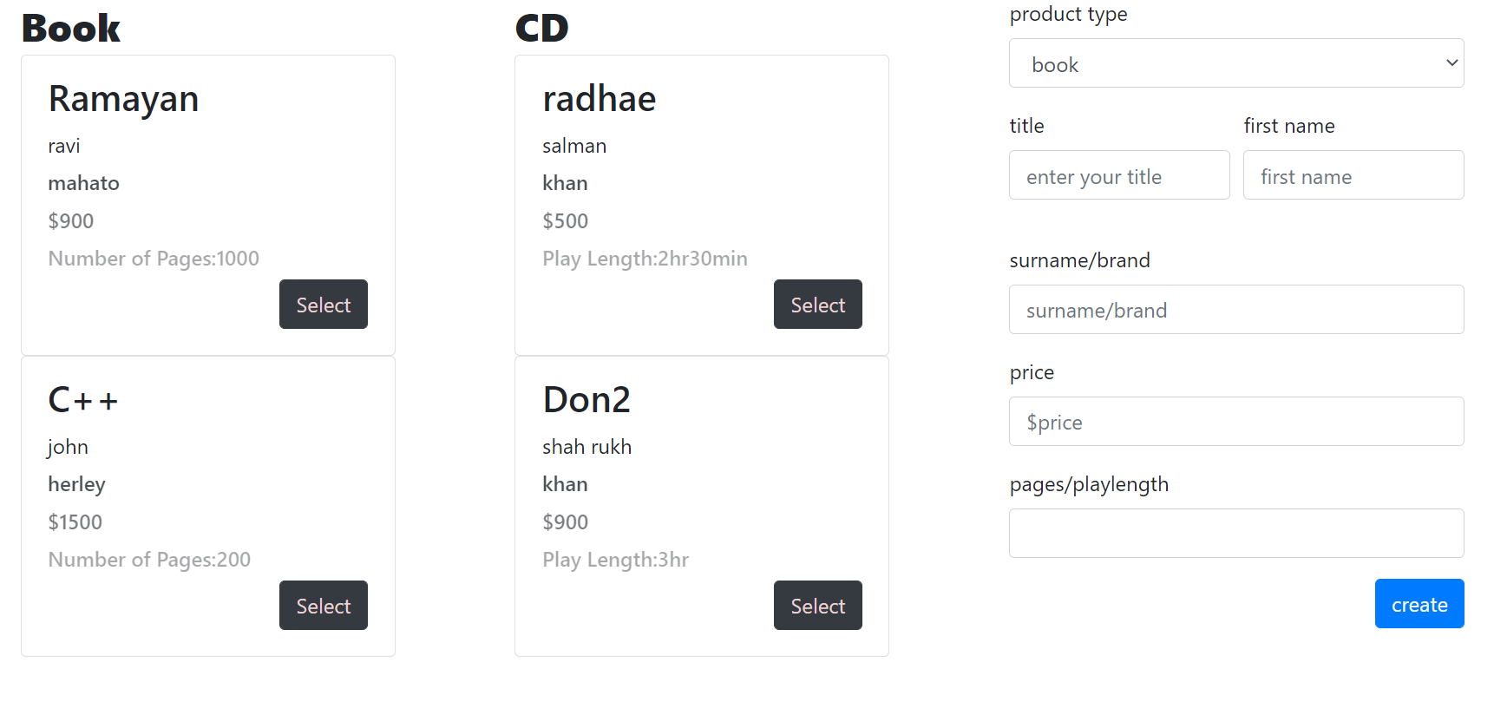

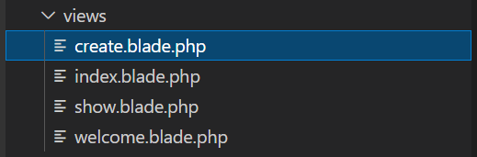
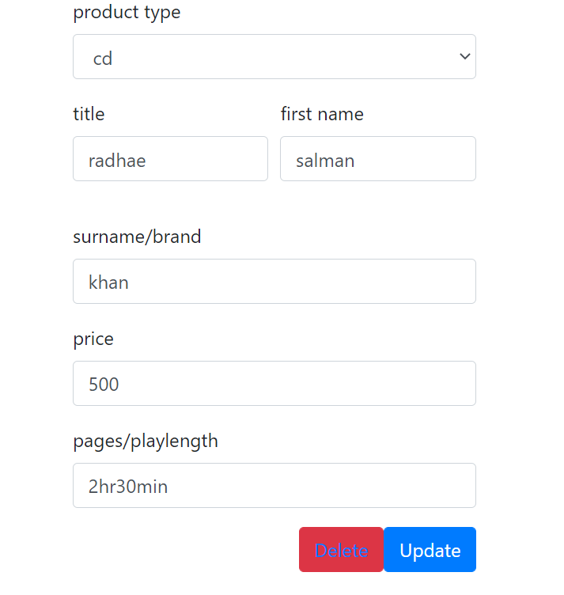

Evidence of route
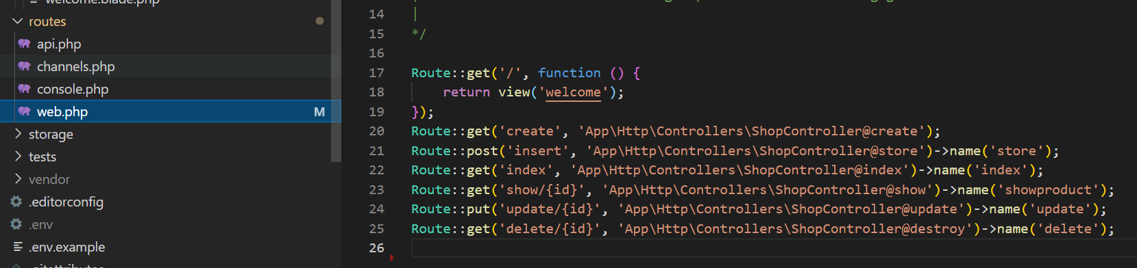

Evidence of controller
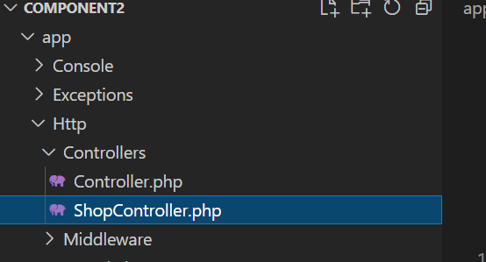

Evidence of version control
Github link for component-2
https://github.com/rajanish9007/component2

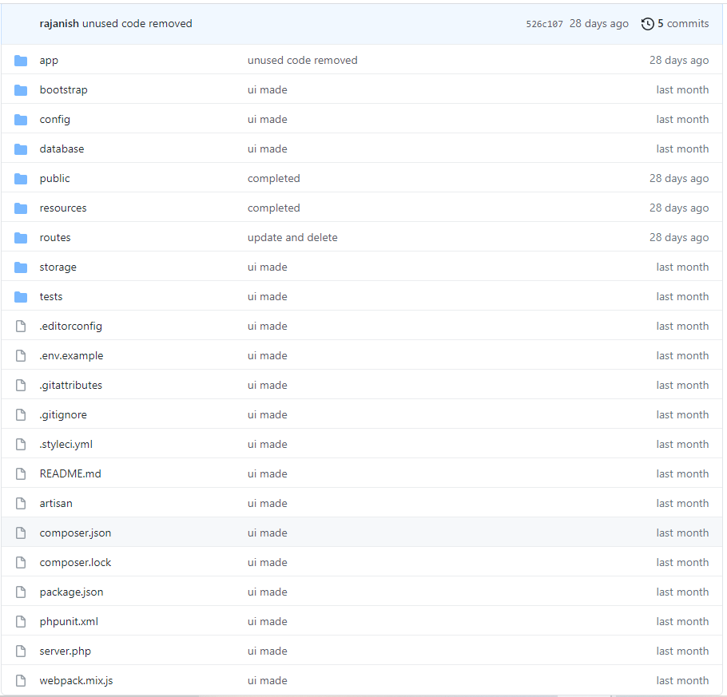

Component-3
Component-3 is extension of component-2 ,in this component I’ve use same file of previous project also created and developed following element
- models and migrations (removing the earlier use of the json file)
- factories/seeders (for seeding large data sets)
- routing (named routes)
- views (blade or Vue )
- responsive UI/UX
- controllers (Resource Controllers/ User defined Controllers)
- authentication
- password reset
- authorization (using Gate or authorize)
- eloquent ORM

evidence of ui/ux
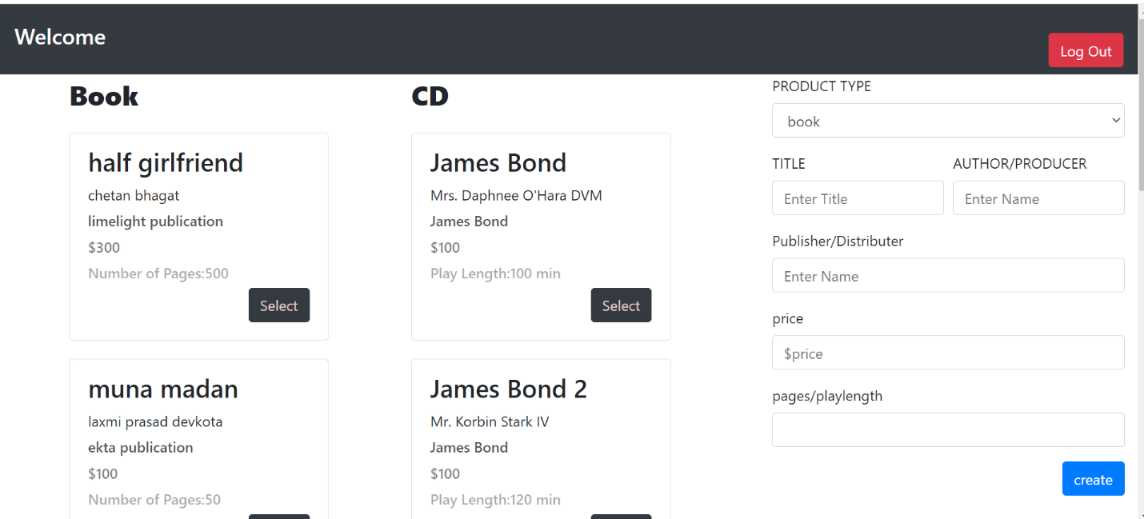
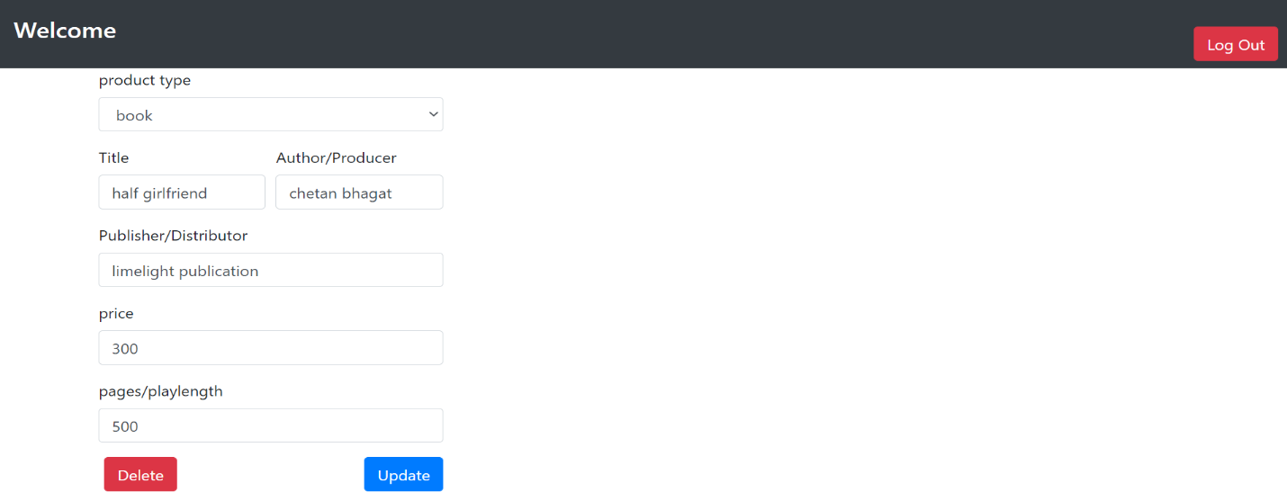

evidence of model and migration
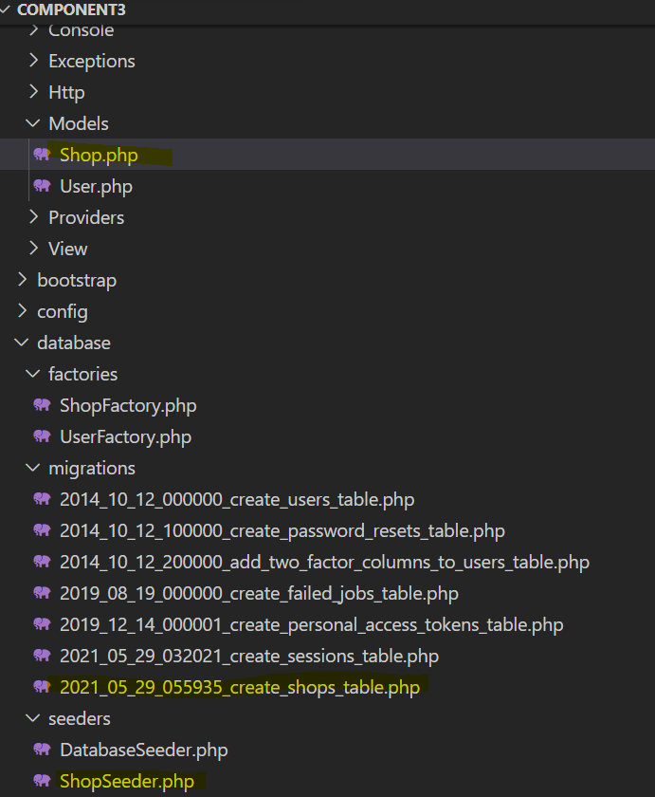

evidence of factories/seeders
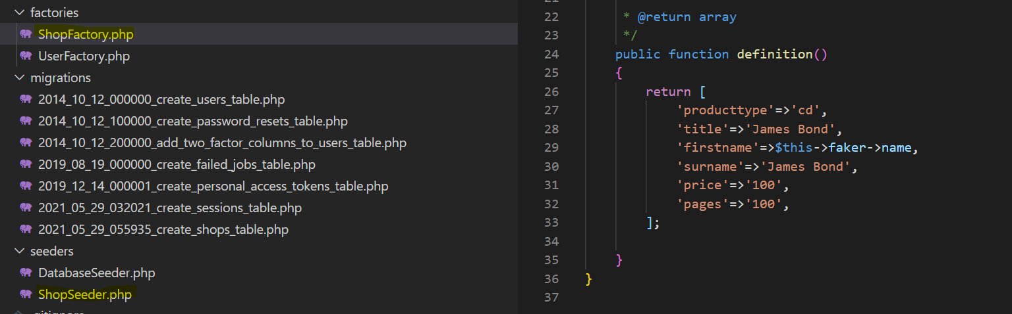

evidence of routing
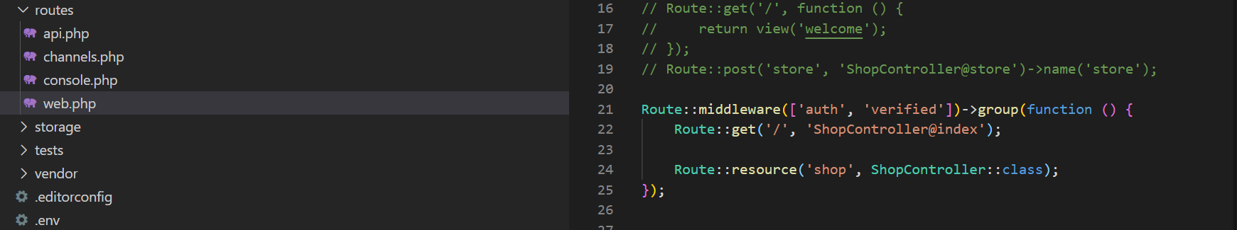

evidence of view
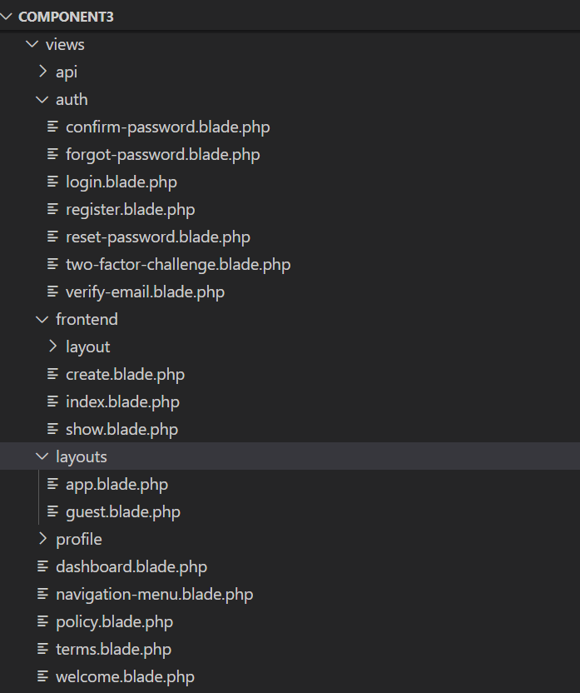

evidence of controller
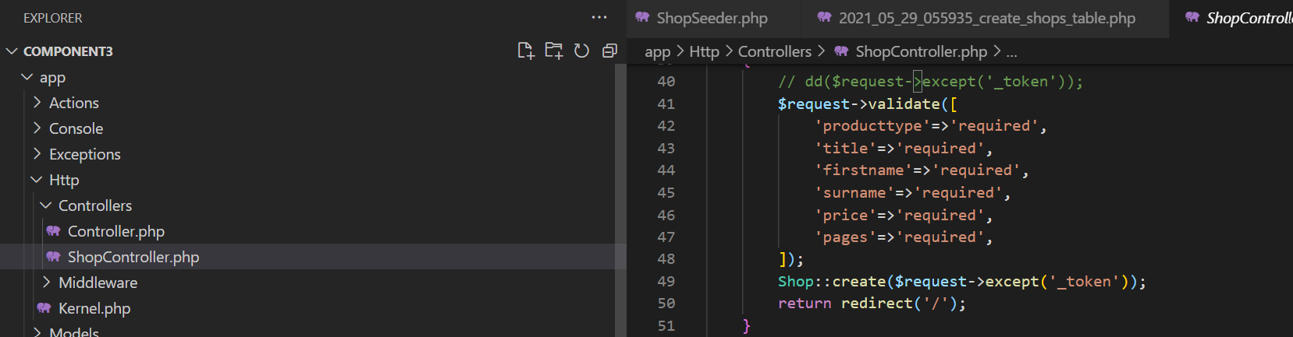

evidence of authentication
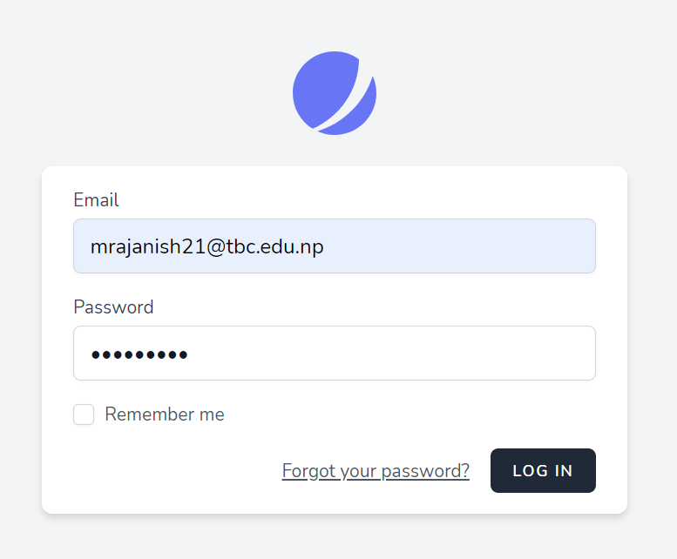

evidence of password reset
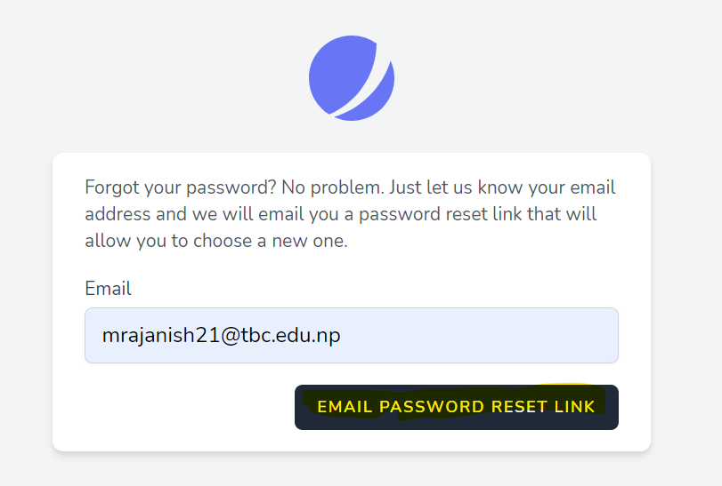
Git hub link of component 3: https://github.com/rajanish9007/component3

